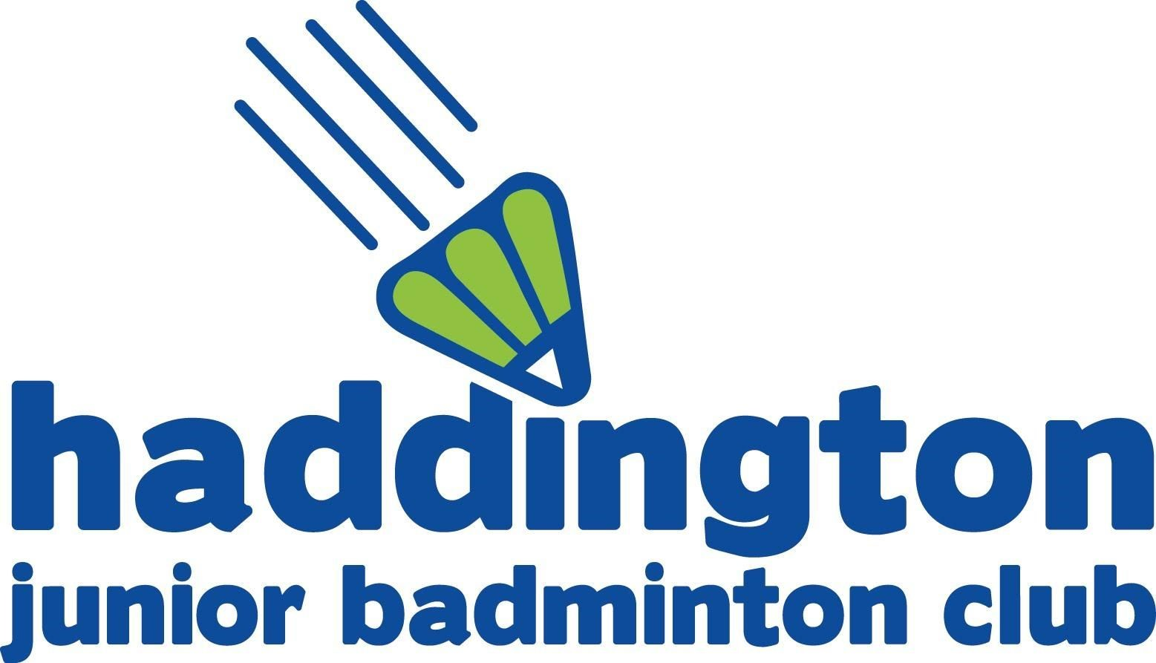
T-Shirt / Hoodie Order
2017­2018 Season

Name of Child:

Group: | Tues / Weds | Beginner | Intermediate | Advanced | Progressive
Please circle group day and level so we can deliver order

CLUB TSHIRT ORDER
Size: | Age 7-8 | Age 9-11 | Age 12-13 | Adult Small / Large | £10.00

CLUB HOODIE ORDER
Size: | Age 7-8 | Age 9-11 | Age 12-13 | Adult Small / Large | £20.00
Style: | Zip-up (red contrast zip) |  | Pull-Over
Name on sleeve
……………………………………………………………………………………………..........................................................
Please write name in CAPS. If you do not want a name printed on sleeve, leave blank.

Name will be printed down Right arm. Please pay at the time of ordering. Due to the individual nature of the printing, orders will only be placed once payment has been received.
For sizes please use the club T-Shirt as a guide, the hoodies are the same brand/manufacturer. Adult Small covers age 14-15. Child pull-over will not have string toggles.
Any questions please email haddingtonjbc@gmail.com

Cash | Cheque |  | Online | Amount paid £
Online payments please reference child full name.
Account number 00439692 Sort code 80-08-23
Please make cheques payable to Haddington Junior Badminton Club.
Signed: |  | Printed: |  |  | Date:

