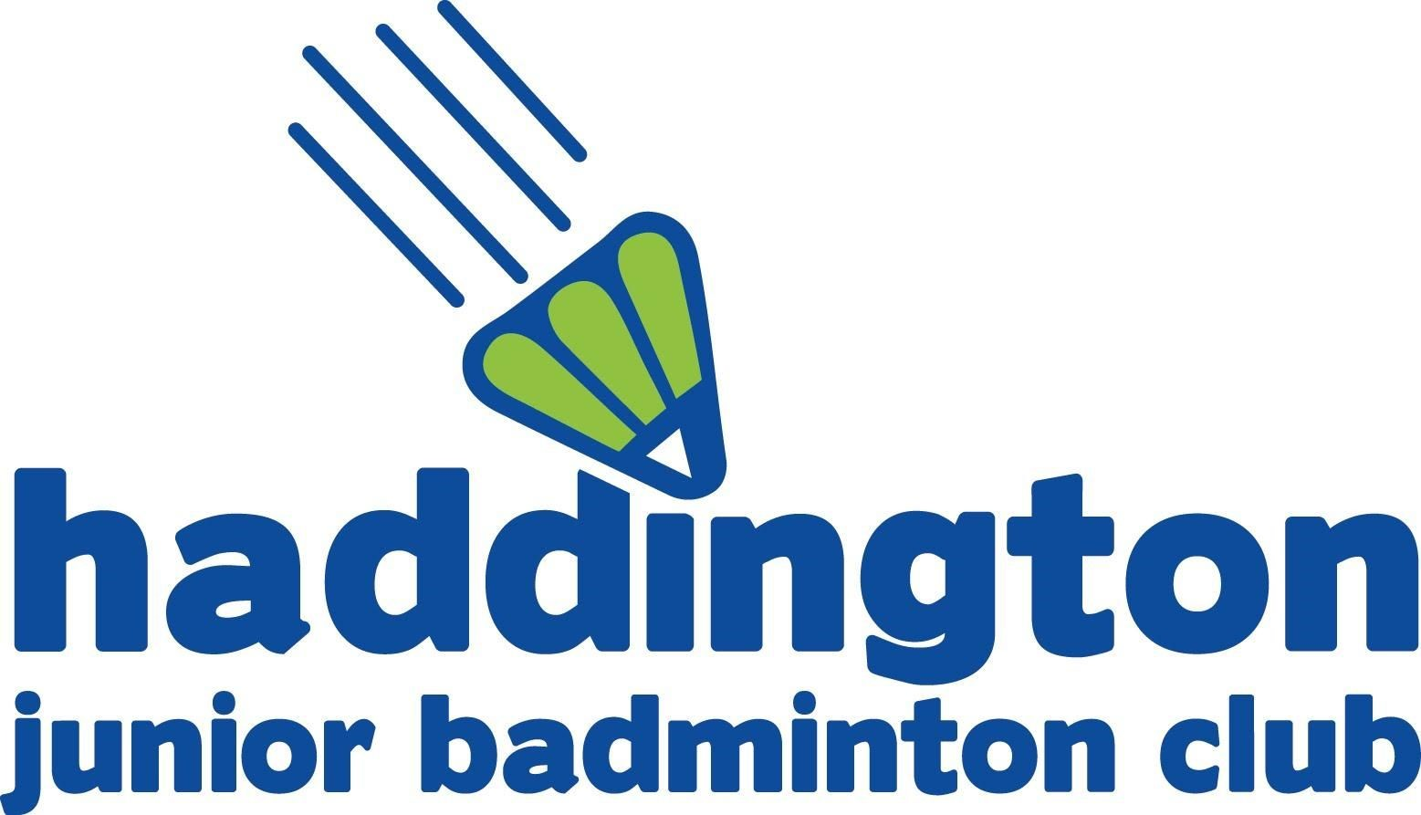
T-Shirt / Hoodie Order
2018­2019 Season

Name of Child: Group:

CLUB TSHIRT ORDER
Size: | Age 7-8 | Age 9-11 | Age 12-13 | Adult Small / Large | £10.00

Cheque | Online | Amount paid £

CLUB HOODIE ORDER
Size: | Age 7-8 | Age 9-11 | Age 12-13 | Adult Small / Large | £25.00
Style: | Zip-up (red contrast zip) |  | Pull-Over
Name on sleeve – will be printed down Right arm, if this is left blank no name will be printed.
……………………………………………………………………………………………..........................................................
PLEASE WRITE NAME IN CAPITALS

Cheque | Online | Amount paid £

Please pay at the time of ordering. Due to the individual nature of the printing, hoodie orders will only be placed once payment has been received.
Please note that Adult Small covers age 14-15. Child pull-over hoodie will not have string toggles.
Any questions please email haddingtonjbc@gmail.com
Online payments please reference child full name
Account number 00439692 Sort code 80-08-23
Please make cheques payable to Haddington Junior Badminton Club. NO CASH PLEASE!
Signed: | Printed: | Date:

